Kingdom of Saudi Arabia  Ministry of Education  Hafr Al Baten Educational Directorate for boys  Tarbeat Al –Ajial International Schools |  |  |  |   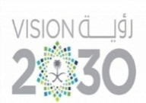 |  |  | Date: / / 2025  Subject: Computer  Class.: 2
……………… |  | Seat Number |  | ……………………………………….. |  |  |  | Student’s Name
Final Exam (1st Semester) 2025/2026
Sign. | Consultative Name |  | Sign. |  | Corrector’s Name | Marks in letters |  |  | Marks  in numbers
 |  |  |  |  |  |  |  |  | 40

Q1: Match the following:
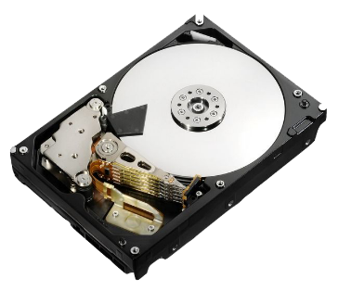 | Folder
 | Hard Disk
 | C: Drive
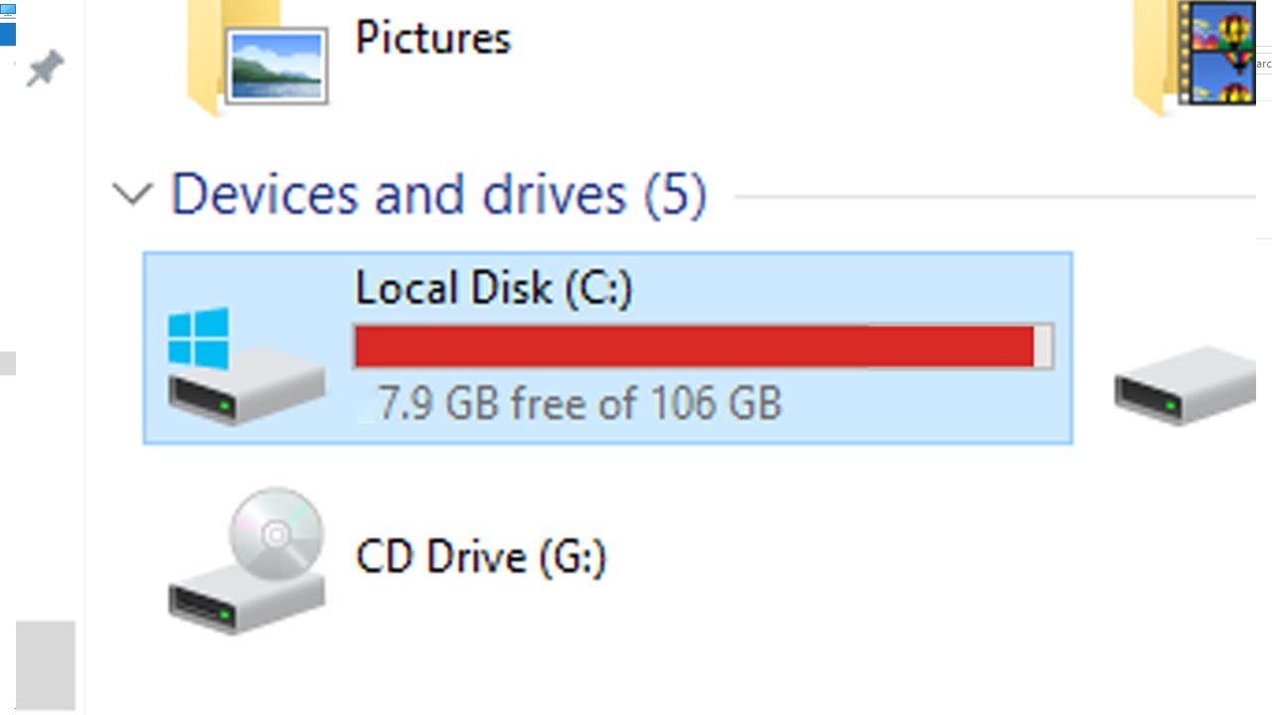 | File

Q2: Match the following:

 | Image | 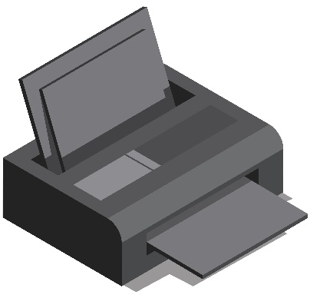 | Scanner
 | Recycle Bin |  | Mouse
 | Music | 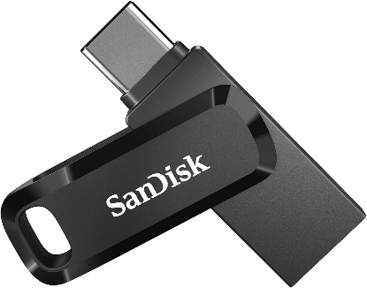 | Flash Drive
 | Alt |  | Ctrl
 | Shift | 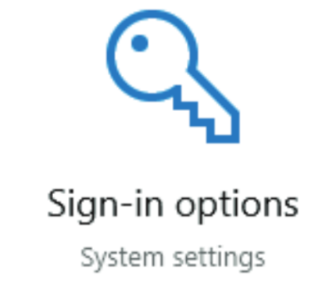 | Sign-in

Good Luck

